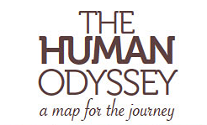
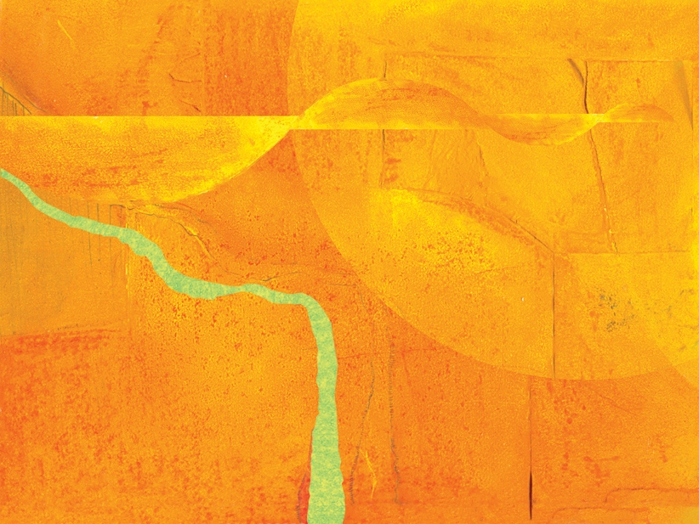
presents
The Art of Mindfulness

Registration
The Art of Mindfulness
Program Begins: 1ST or 2nd February 2011 and then ongoing
Contact: humanodyssey@iinet.com.au Nicky: Ph 03 9386 8512 Magi: Ph. 03 9754 4193
Payment in Full  Please tick type of payment  Cash <INPUT TYPE=\ Cheque <INPUT TYPE=\ EFT <INPUT TYPE=\ Credit Card <INPUT TYPE=\  (See below for form)  Early Bird: $378 (pay on or before start date)  Full Fee: $420 | Payment by Session  Please tick type of payment  Cash <INPUT TYPE=\ Cheque <INPUT TYPE=\ EFT <INPUT TYPE=\ Credit Card <INPUT TYPE=\  (See below for form)  Each workshop: $65
EFT Details for Payment via Internet:
Name of Account: Nicky McCartney BSB: 063 575 Account No: 1002 5496

Your Name:

Your Address and Telephone No:

Payment by Credit Card
Includes 3.88% bank surcharge
Early Bird (whole term): $392.66 (pay on or before start date)  Full Fee (whole term): $436.30 | Each Session: $67.52
Mastercard <INPUT TYPE=\ VISA <INPUT TYPE=\ AMEX <INPUT TYPE=\
please tick
Name on Card: | Card No:  __ __ __ __ __ __ __ __ __ __ __ __ __ __ __ __
Signature: | Expiry:  ______/______

